[**DESIGN PATTERNS AND PRINCIPLES**](https://github.com/Karthiga042/Cognizant-Java-FSE/tree/main/Week%201/Design%20Patterns%20and%20Principles)

**EXERCISE 1: IMPLEMENTING THE SINGLETON PATTERN**

**Logger.java**

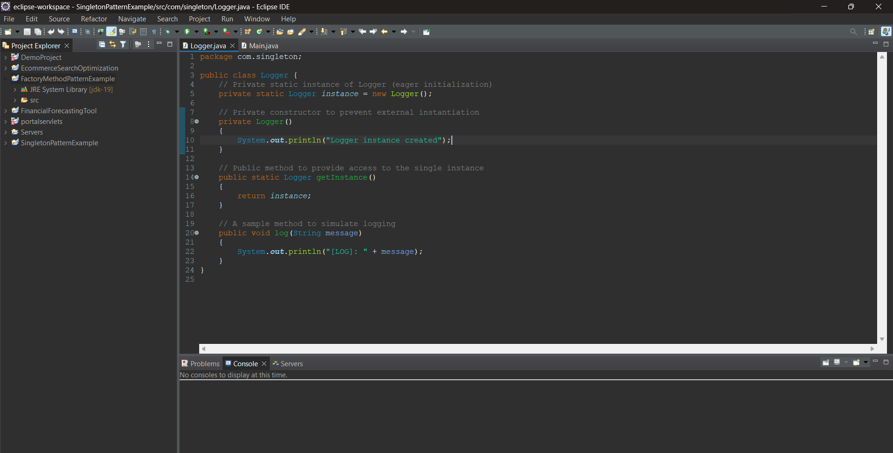

**Main.java**

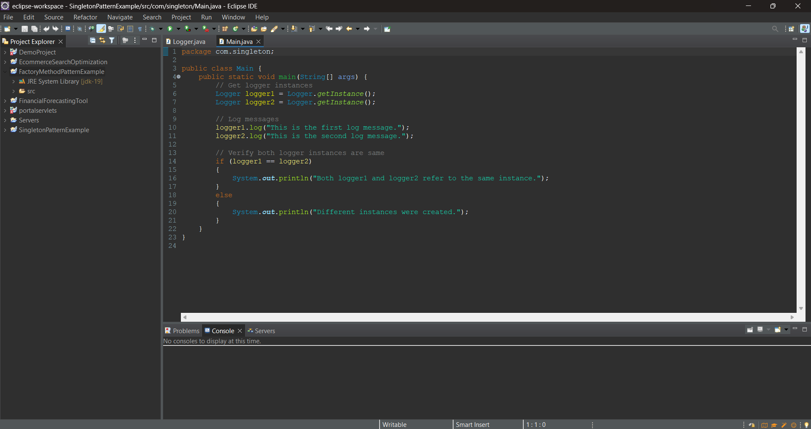

**Output:**

